

|  |
| --- |
| **BATCH AND ROLL NO: R6 - 42257** |
| **EXPERIMENT NO.7** |
| **TITLE:** Design a mobile application using image slider to show images. |
| **DATE OF PERFORMANCE** |
| **DATE OF CHECKING** |

**Title:** Design a mobile application using image slider to show images.

**Requirements:**

1 Android studio

1. Image Slider Library

**Theory:**

An image slider in an Android app is a UI component that allows the user to swipe horizontally through a set of images. It's commonly used in various types of apps, such as photo galleries, e- commerce apps, and social media apps.

An image slider is typically implemented using a third-party library that provides the necessary functionality, such as ViewPager2, ImageSlider, or CarouselView. These libraries handle the image loading, swipe gestures, and navigation controls, allowing the developer to focus on customizing the appearance and behavior of the slider.

To use an image slider in your Android app, you will typically need to add the library as a dependency in your app's build.gradle file, define the layout for the slider in your XML file, and implement an adapter to populate the slider with images. You can then customize the slider's appearance and behavior as needed, using the library's configuration options and callbacks.

Some popular features that are often included in an image slider are:

* + Swipe gestures to navigate through images
  + Navigation controls such as dots or arrows to indicate the current position
  + Auto-play option to automatically move through images
  + Image captions or titles
  + Zooming and panning options for individual images

When designing an image slider, it's important to consider the user experience and ensure that the slider is intuitive and easy to use. It's also important to optimize image loading and caching to ensure that the slider performs well and doesn't consume excessive memory or bandwidth.



Here are the general steps to add an image slider to your Android app project:

1. Choose a third-party library that provides image slider functionality, such as ViewPager2, ImageSlider, or CarouselView.
2. Add the library dependency to your app's build.gradle file.
3. Define the layout for the image slider in your XML file. This will include the slider container and any other layout elements you want to include, such as captions or navigation controls.
4. Define the adapter to populate the image slider with images. This will include creating a custom adapter class that extends the appropriate adapter class from the library, and implementing the methods to load images into the slider.
5. Initialize the image slider in your activity or fragment code, using the adapter and layout elements you defined in steps 3 and 4.
6. Customize the image slider's appearance and behavior as needed, using the library's configuration options and callbacks.

The specific steps and code required will depend on the library you choose and the features you want to include in your image slider. It's important to follow the library's documentation and sample code closely to ensure proper integration and functionality.

**Code:**

**package com.example.myapplication; import android.os.Bundle;**

**import androidx.appcompat.app.AppCompatActivity;**

**import com.denzcoskun.imageslider.ImageSlider;**

**import com.denzcoskun.imageslider.constants.ScaleTypes; import com.denzcoskun.imageslider.models.SlideModel;**

**import java.util.ArrayList; import java.util.List;**

**public class MainActivity extends AppCompatActivity {**

**@Override**

**protected void onCreate(Bundle savedInstanceState) { super.onCreate(savedInstanceState); setContentView(R.layout.activity_main);**

**ImageSlider imageSlider=findViewById(R.id.slider1);**

**List<SlideModel> slideModelList=new ArrayList<>(); slideModelList.add(new SlideModel(R.drawable.cat,"1", ScaleTypes.FIT)); slideModelList.add(new SlideModel(R.drawable.dog,"2",ScaleTypes.FIT)); imageSlider.setImageList(slideModelList);**

**}**

**}**



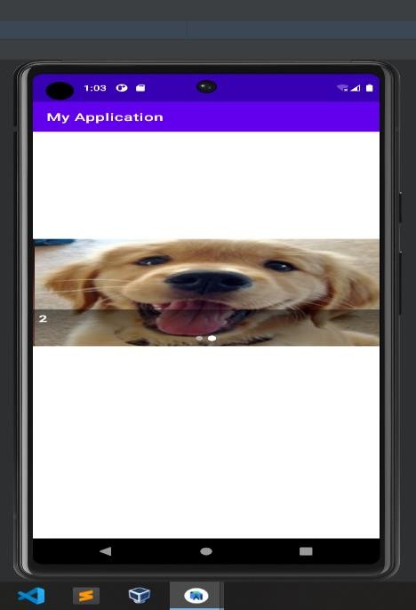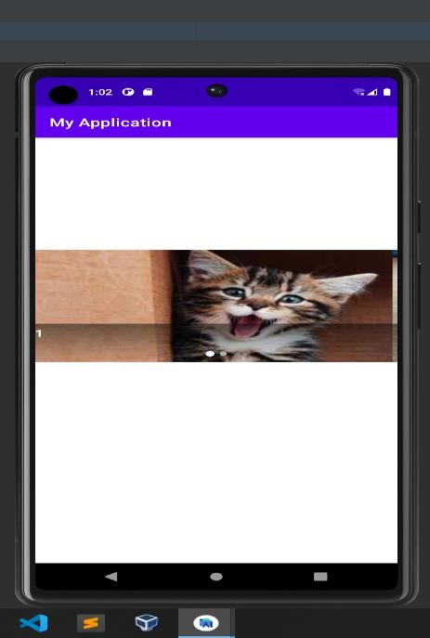

**Output:**

**CONCLUSION:**

**……………………………………………………………………………………………**

**……………………………………………………………………………………………**

**……………………………………………………………………………………………**